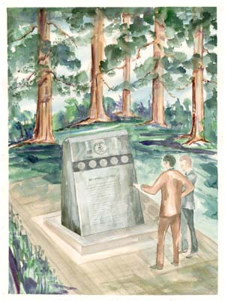
SEQUOIA VETERANS MEMORIAL

The Sequoia Veterans Memorial is a granite monument to be erected on the Sequoia High School campus honoring students who attended Sequoia and died while in the military.

Tax-deductible donations in any amount are being sought to fund the purchase, engraving and erection of the monument. Dedication stones are being sold for $100 each and will form a path to the monument. To purchase a dedication stone honoring a family member or friend, please complete the form below and send it with your check for $100. Please make all checks payable to: Sequoia Veterans Memorial.

Information and/or tax-deductible donations should be sent to:

Sequoia Veterans Memorial
c/o Dee Eva
P. O. Box 3868
Redwood City, CA 94064-3868
- - - - - - - - - - - - - - - - - - - - - - - - - - - - - - - - - - - - - - - - - - - - - - - - - - - - - - - - - - - - - - - - - - - - - - - - - - - - -
Memorial Monument List - Sequoia Student Information:
Name: ____________________________________________________________________________________________
First Middle Last
Year(s) attended/graduated Sequoia_______________ Date of Birth ___________________________________________

Branch of Service ___________________________________ Rank__________________________________________
Army Navy Marines Air Force Coast Guard
Serial Number or Social Security Number_________________________________________________________________

Years of Service in the military _________________________________________________________________________

War or Conflict Served In______________________________________________________________________________

Date of Death ______________Place of Death _________________Place of Burial _______________________________
- - - - - - - - - - - - - - - - - - - - - - - - - - - - - - - - - - - - - - - - - - - - - - - - - - - - - - - - - - - - - - - - - - - - - - - - - - - -
Dedication Stone Information: Please allow a space for word breaks and periods. Please print and indicate capital and lower case letters with a maximum of 20 characters per line.

___ ___ ___ ___ ___ ___ ___ ___ ___ ___ ___ ___ ___ ___ ___ ___ ___ ___ ___ ___

___ ___ ___ ___ ___ ___ ___ ___ ___ ___ ___ ___ ___ ___ ___ ___ ___ ___ ___ ___

___ ___ ___ ___ ___ ___ ___ ___ ___ ___ ___ ___ ___ ___ ___ ___ ___ ___ ___ ___

Your name___________________________________________ Phone ________________________________________

Address _________________________________________________________________________________________

FOR FURTHER INFORMATION, PLEASE CONTACT:
DEE EVA
650-368-4800 Fax 650-368-6857
Email: dee@deeeva.com
Web Site: www.sequoia61.com
REVISED 2-12-04

